Congenital Disorders of the Lower Respiratory System

**Prereading**

Development of the Respiratory System

**Learning Objectives**

After completing this brick, you will be able to:

* Define congenital disorders of the lower respiratory system and neonatal respiratory failure.
* Explain the causes, clinical features, and management of tracheal atresia and tracheoesophageal fistula.
* Explain the cause, clinical features, and management of congenital pulmonary hypoplasia.
* Explain the cause, clinical features, and management of bronchogenic cysts.
* Explain the cause, clinical features, and management of congenital diaphragmatic hernia.

AD is a newborn infant in respiratory distress in the newborn nursery. She was born earlier today by vaginal delivery at 40 weeks’ gestation. She is breathing rapidly and has a barrel-shaped chest and a scaphoid (concave) abdomen. Bowel sounds are heard on the left side instead of breath sounds.

What is most likely wrong with AD, and what should be done for her? Consider your answer as you read, and we’ll revisit AD at the end of the brick.

**What Are Congenital Disorders of the Lower Respiratory System?**

**Congenital disorders of the lower respiratory system are important to detect either pre- or immediately postnatally, since a consequence of any of these can be neonatal respiratory failure. This is the inability of a newborn to ventilate (exchange carbon dioxide between the blood and the atmosphere) and/or oxygenate (transfer oxygen from lungs to blood). In some cases, respiratory failure may become apparent immediately after birth and threaten the infant’s life, so early recognition is important.**

If present, neonatal respiratory failure may present as tachypnea, nasal flaring, retractions of the respiratory muscles, and grunting in the newborn or infant. Cyanosis is commonly evident. Some newborns will also present with a temporary pause in breathing (apnea).

In this brick we will discuss several of the most common of these disorders, including tracheoesophageal fistula, pulmonary hypoplasia, bronchogenic cysts, and congenital diaphragmatic hernia. Each of these is a consequence of abnormal development in utero.

Q: What clinical signs in neonates indicate respiratory failure?

A: Signs indicate respiratory failure in a neonate are tachypnea, nasal flaring, retractions of the respiratory muscles, and grunting.

**What Are Common Tracheal Anomalies?**

Tracheal anomalies include tracheal atresia and tracheoesophageal fistula. They arise from abnormal tracheal development and division (septation) from the esophagus.

During the embryonic stage of respiratory development, in weeks 4 through 7 of gestation, the lung bud buds off from the primitive foregut (Figure 1).

**Figure 1 Development of the trachea and esophagus**

12899

If development follows the normal path, the lung bud becomes the trachea and bronchi, with subsequent branching into small airways. The foregut becomes the mature esophagus. The trachea and esophagus are divided by a septum which prevents food from entering the respiratory tract. However, if anything along this pathway goes awry, tracheal and/or esophageal abnormalities result, often creating a connection between the two tubes.

**Tracheoesophageal Fistula**

Improper septation of the lung bud from the esophagus can give rise to a tracheoesophageal fistula (TEF), an abnormal connection between the respiratory tract to the gastrointestinal (GI) tract. TEFs are often associated with esophageal atresia (EA), where the infant is missing all or part of the esophagus.

The types of TEFs with esophageal atresia (EA) are shown in Figure 2. The most common type is EA with a distal TEF.

**Figure 2 Tracheoesophageal fistula with esophageal atresia**

182162

TEFs with EA result from a defect in early development of the respiratory tract during the embryonic stage, usually from improper septation between the trachea and esophagus. Half of all TEFs are accompanied by other congenital anomalies, particularly of the heart, bones, and kidneys.

Q: How does a tracheoesophageal fistula (TEF) form?

A: TEFS form from improper septation between the lung bud and the esophagus during development.

**Clinical Presentation.** Because TEFs with EA prevent a fetus from swallowing amniotic fluid in utero, most of them are detected prenatally due to **polyhydramnios**—meaning more amniotic fluid than expected is found on ultrasound.

After birth, most affected neonates are immediately symptomatic. Excessive secretions from the proximal esophagus lead to coughing, choking, drooling and cyanosis. The respiratory distress is from fluid in the lungs and/or aspiration pneumonia. The infant is also unable to feed since the esophagus often ends in a blind pouch.

**Diagnosis.** If not detected prenatally by ultrasound, the diagnosis can be confirmed after birth; on chest x-ray a tube (NG tube) placed into the esophagus will not reach the stomach (seen as the gastric air bubble in Figure 3).

**Figure 3 Tracheoesophageal fistula**

183221

The distal GI tract will be filled with gas in those TEFs where the trachea and distal esophagus communicate.

**Management.** Management of TEFs with esophageal atresia is surgical. The fistula tract is removed, and the upper esophagus is connected with the lower GI tract.

If the infant has only a TEF with EA, the prognosis is usually good. However, if associated with other congenital anomalies, the prognosis is determined by the extent of other concurrent abnormalities.

**Tracheal Atresia**

Failure of the lung bud to develop fully leads to tracheal atresia, in which the trachea is completely or partially absent. This is usually fatal, unless an associated proximal TEF is present, allowing a tube to be inserted through the esophagus into the lower airways.

Neonatal respiratory failure is present immediately after birth, and the lungs are most often underdeveloped.

**What Is Pulmonary Hypoplasia?**

Pulmonary hypoplasia is incomplete development of the lungs, leading to fewer distal airways, alveoli, and pulmonary vessels.

Pulmonary hypoplasia can be primary (genetic) or secondary to other diseases or environmental causes. The most common secondary causes are:

* **Oligohydramnios**: this is insufficient amniotic fluid, which is vital for lung development and physical expansion of lung tissue during fetal breathing movements. Oligohydramnios can be the result of fetal renal dysfunction (the fetal kidney does not make the amniotic fluid) or placental abnormalities.
* **Space-occupying lesions compressing the developing lung**: an enlarged heart or a congenital diaphragmatic hernia can anatomically impede lung growth.
* **Abnormal diaphragmatic activity**: central nervous system or musculoskeletal disease (including congenital diaphragmatic hypoplasia, see below) can result in reduced motion of the diaphragm. This leads to an inability to properly expand lung tissue during fetal “inhalation.” Although a fetus does not breathe in air, breathing movements in utero bring amniotic fluid into the respiratory system for alveolar expansion and lung development.

Q: How does oligohydramnios lead to neonatal respiratory distress?

A: Oligohydramnios can lead to neonatal respiratory distress because the amniotic fluid plays a vital role in the physical expansion of the lungs during fetal breathing movements and pulmonary development.

**Diagnosis**

Pulmonary hypoplasia is typically a clinical diagnosis based on vital signs and physical examination, usually showing **respiratory distress at birth**.

Chest X-rays can be used to determine to demonstrate small, poorly expanded lungs, as shown in Figure 4, an infant with bilateral pulmonary hypoplasia due to congenital diaphragmatic hernia (note the small right lung). Also note the bowel filling the left thorax, and secondarily inhibiting development of both lungs.

**Figure 4 Congenital diaphragmatic hernia causing pulmonary hypoplasia**

183265

**Management**

Management includes support with oxygen and ventilation and prompt correction of underlying secondary causes (eg, surgical correction of diaphragmatic hernia).

**What Are Bronchogenic Cysts?**

Bronchogenic cysts are saclike structures within the lung. They are lined internally by respiratory epithelium, with walls made up of cartilage and smooth muscle—a structure similar to that of the normal tracheobronchial tree. A bronchogenic cyst is most often a fluid-filled blind pouch but occasionally may communicate with normal airways within the lung.

These cysts result from either incomplete budding from the primitive foregut or early termination of respiratory airway branching. Because they form early in the development of the respiratory system, these cysts are typically located within the mediastinum, near or at the carina of the trachea.

**Clinical Presentation**

Most bronchogenic cysts are asymptomatic at birth and are detected on chest radiographs done for other reasons. Some are found in teenagers who present with recurring episodes of cough, wheezing, and pneumonia. In rare cases, they may cause respiratory distress in the infant, but only if the cyst is rapidly enlarging and/or compressing nearby structures such as the heart.

**Diagnosis**

On chest x-ray, a bronchogenic cyst will appear as an opaque structure, sometimes with an air-fluid level—the fluid coming from secretions of the cyst’s respiratory epithelial lining. After repeated infections, the cyst fills up with gas and appears as a dark mass on chest x-ray (Figure 5).

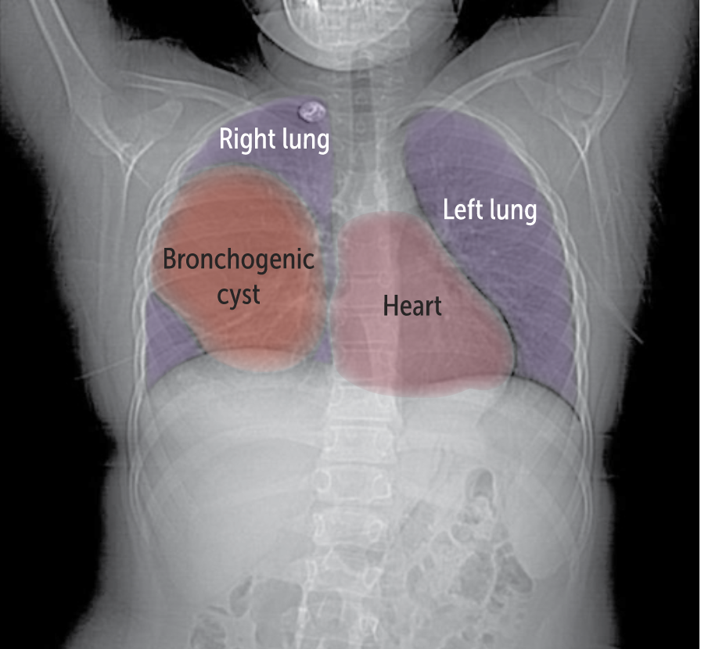

**Figure 5 Bronchogenic cyst**

183179

**Management**

A bronchogenic cyst is treated with surgery. Many surgeons will recommend removal of even asymptomatic cysts because of the small risk of malignant transformation over time. Surgical resection is curative, and most patients live without further symptoms

**What Is Congenital Diaphragmatic Hernia?**

A congenital diaphragmatic hernia (CDH) is a “can’t-miss” diagnosis of infants in neonatal respiratory distress at or after birth. As we’ve already learned, CDH is a secondary cause of pulmonary hypoplasia. With or without hypoplasia, CDH can cause neonatal respiratory distress.

CDH is caused by a developmental defect in the diaphragm that allows abdominal contents to protrude up into the thoracic cavity. Most are on the left side (Figure 6).

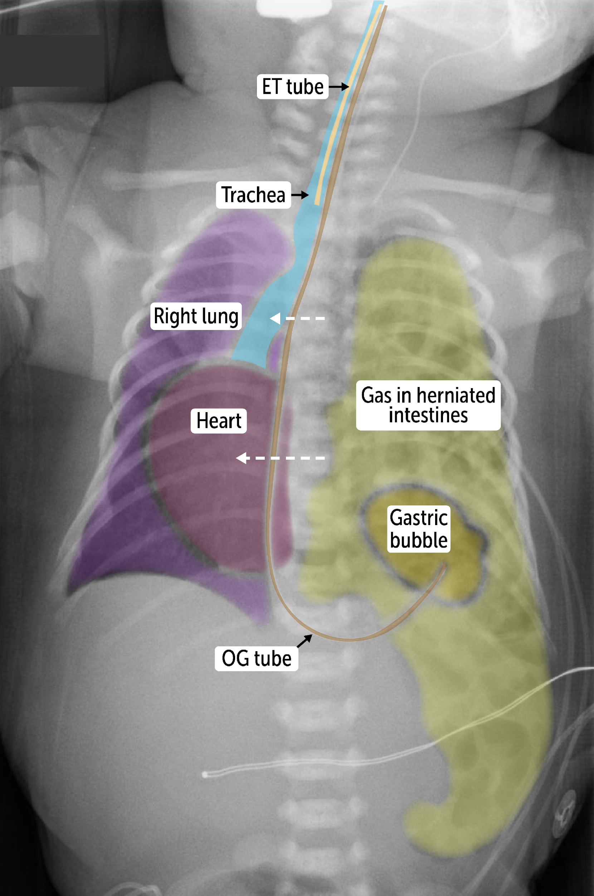

**Figure 6 Left Congenital diaphragmatic hernia**

183198

CDH occurs in 1 in 2500 births. Unlike TEFs, most CDHs are isolated; as many as 30% are associated with other congenital anomalies.

**Clinical Presentation**

Approximately half of CDHs are detected on prenatal ultrasound by 24 weeks’ gestation. This implies that herniation occurs during a critical period of lung development, which leads to increased lung compression and a high risk of pulmonary hypoplasia (see Figure 4).

CDH often leads to **respiratory distress** at birth. The degree of respiratory distress (and hypoplasia) is dependent on the degree of herniation, which determines the severity of lung hypoplasia.

**Diagnosis**

On physical exam, infants with severe CDH will typically have a scaphoid, or sunken and hollow, abdomen because the intestines have protruded into the thorax. They will also have a barrel-shaped chest due to the intestinal protrusion. Bowel sounds may be heard on auscultation of the chest.

A chest X-ray will usually show the herniation (see Figure 6).

**Management**

Acutely after birth, there is a high risk of pulmonary hypertension and respiratory failure, making oxygenation of the blood very difficult. Therefore, management of CDH usually involves immediate **intubation with mechanical ventilation**, placement of an OG tube, and **urgent surgery** to correct the defect. Afterwards, infants and children are at greater risk of lung infection, obstructive lung disease, gastrointestinal reflux disease, and recurrent diaphragmatic hernia later in childhood.

At large academic medical centers, survival rates of >80% have been reported with surgery.

Q: What are typical physical findings in an infant with severe CDH?

A: The physical examination of infants with severe CDH will show a scaphoid, or sunken and hollow, abdomen and a barrel-shaped chest, along with some degree of respiratory distress.

Thinking back to AD, what is wrong with her, and what should be done now?

Based on the respiratory distress and bowel sounds in the thorax, you suspect a congenital diaphragmatic hernia. This is confirmed after you get a stat chest X ray. Because AD is in distress, she is intubated endotracheally and ventilated. To the relief of her family, emergent surgery corrects the hernia. You tell her family that AD’s prognosis is now excellent, but she may have increased risk of lung infections in the future.

**Summary**

**Congenital Disorders of the Lower Respiratory Tract**

* Anatomic anomalies of the lower respiratory system can lead to neonatal respiratory failure.
* Neonatal respiratory failure is the inability of a newborn to ventilate and/or oxygenate.

**Tracheal Disorders**

* Failure of tracheal development may lead to tracheoesophageal fistula or tracheal atresia.
* Abnormal septation between the trachea and esophagus can lead to tracheoesophageal fistula with esophageal atresia.
* The diagnosis can be confirmed with a chest x-ray.
* Management is surgical, and the prognosis is good if the infant has and isolated TEF.

**Pulmonary Hypoplasia**

* The main causes of pulmonary hypoplasia are oligohydramnios and space occupying lesions in the thorax, such as congenital diaphragmatic hernia.
* It is typically a clinical diagnosis, but the secondary cause may be seen on chest radiography.
* Management includes correction of the secondary cause, supplemental oxygen ventilation and supportive care to promote lung function and survival.

**Bronchogenic Cysts**

* Bronchogenic cysts are usually midline remnants of failed lung development
* They are often asymptomatic at birth but may become symptomatic when teenagers present with recurring episodes of cough, wheezing, and pneumonia.
* On chest x-ray it appears as an opaque structure with an air-fluid level.
* They are removed surgically.

**Congenital Diaphragmatic Hernia**

* CDH develop when intestinal contents herniate up into the thoracic cavity, compressing the developing lung.
* They are a secondary cause of pulmonary hypoplasia.
* The severity of respiratory distress and lung hypoplasia is directly related to the degree of herniation.
* Management includes intubation, mechanical ventilation, placement of OG tube and surgery to correct the defect.

**Review Questions**

1. A neonate had polyhydramnios detected on prenatal ultrasound. At birth, he is cyanotic and drooling, has intercostal retractions, and has difficulty feeding. What is the most likely diagnosis?

1. Bronchogenic cyst
2. Congenital diaphragmatic hernia
3. Pulmonary hypoplasia
4. Potter sequence
5. Tracheoesophageal fistula

2. Which of the following complications is most likely in a patient with congenital diaphragmatic hernia?

1. Bronchogenic cysts
2. Polyhydramnios
3. Pulmonary hypoplasia
4. Tracheal atresia
5. Tracheoesophageal fistula

3. A teenage girl presents with recurring cough and no relief with over-the-counter medications. Decreased breath sounds are heard in the right middle posterior lung fields. Her chest x-ray shows a midline structure in the right thorax, containing an air-fluid level. Review of prior x-rays shows that the structure was also visible 3 years ago, when the patient had no symptoms. Which of the following is the most likely diagnosis?

1. Bacterial abscess
2. Bronchogenic cyst
3. Lymphoma
4. Pleural effusion
5. Pulmonary tuberculosis

**Answers**

1. The correct answer is tracheoesophageal fistula (E), a cause of neonatal respiratory distress, as seen here. A TEF causes polyhydramnios because the fetus cannot swallow amniotic fluid without a complete esophagus. Bronchogenic cysts (A) are not typically associated with neonatal respiratory distress or amniotic fluid abnormalities. Although congenital diaphragmatic hernia (B) can cause neonatal respiratory distress, it is not associated with amniotic fluid abnormalities. Pulmonary hypoplasia (C) can cause neonatal respiratory distress, but it is also not associated with amniotic fluid abnormalities. Potter sequence (D) is associated with oligohydramnios, not polyhydramnios.

2. The correct answer is pulmonary hypoplasia (C). The compression of the developing lung during diaphragmatic herniation leads to underdevelopment of the pulmonary tissue, causing pulmonary hypoplasia. Other causes include oligohydramnios, an enlarged heart, and an underactive diaphragm that retards fetal breathing. Bronchogenic cysts (A) and tracheal atresia (D) and fistulae (E) are congenital anomalies but are not secondary to diaphragmatic herniation. Polyhydramnios (B) is not a consequence of herniation. It is instead a consequence of esophageal atresia associated with many forms of tracheoesophageal fistulae.

3. The correct answer is bronchogenic cyst (B). Bronchogenic cysts often show up incidentally on chest x-ray but may be associated with recurrent cough, focal abnormalities in breath sounds, and recurrent pneumonia in teens and young adults. Although a bacterial abscess (A) can look cystic with an air fluid level, it is more likely to be acute and highly symptomatic (eg fevers), found within the lung parenchyma, often off midline, and would not have been present 3 years ago. Lymphoma (C) may show up on chest x-ray as nodular opacities in the midline but will not have an air-fluid level. Pleural effusion (D) is incorrect because the meniscus of the fluid buildup appears on the lateral wall of the thorax on x-ray, resulting in costophrenic angle blunting. Pulmonary tuberculosis (E) can occasionally be cystic but is usually seen on chest x-ray as a peripheral, usually apical, opaque nodule—not typically with air-fluid levels and not midline. It would be unlikely that a large TB lesion would remain asymptomatic for several years.